**Game Design Document**

**Fill up the Following document!**

1. Write the title of your project.

The title of my project will be Slingshot Castle War.

1. What is the goal of the game?

The goal of my game is to kill the enemies that are attacking before they destroy the prince and castle.

1. Write a brief story of your game?

The story of my game is that there is a prince left alone in a castle and is trying to protect it by shooting the enemies with rocks on a slingshot because the castle is the only memory and the last thing left from his family, that had died in an a war.

1. Which are the playing characters of this game?

* Playing characters are the ones which respond to the user based on the input from the user.
* Cars, monkeys, dinos, wizards etc, are the playing characters in the game.

|  |  |  |
| --- | --- | --- |
| Number | Character Name | What can this character do? |
| 1 | Prince Amir | This character can shoot the enemies on both sides with rocks on a slingshot |

1. Which are the Non-Playing Characters of this game?

* Non-Playing characters are the ones which don't have an action or a behaviour when the user interacts with the game.
* Hurdles, stones, bananas, coins, etc are non-playing characters in the game.

|  |  |  |
| --- | --- | --- |
| Number | Character Name | What can this character do? |
| 1 | Spaceships | These will be attacking the castle by flying |
| 2 | Enemy | Will be shooting from cannons on random platforms |
| 3 | Maybe there might be ships, depending on the scene | They will attack from the water and shoot |

Draw your imagination of this game. What does this game look like?

* Draw the game either on your computer or on paper,
* Add images of scenes of the game to show each of the playing and non-playing characters at least once.

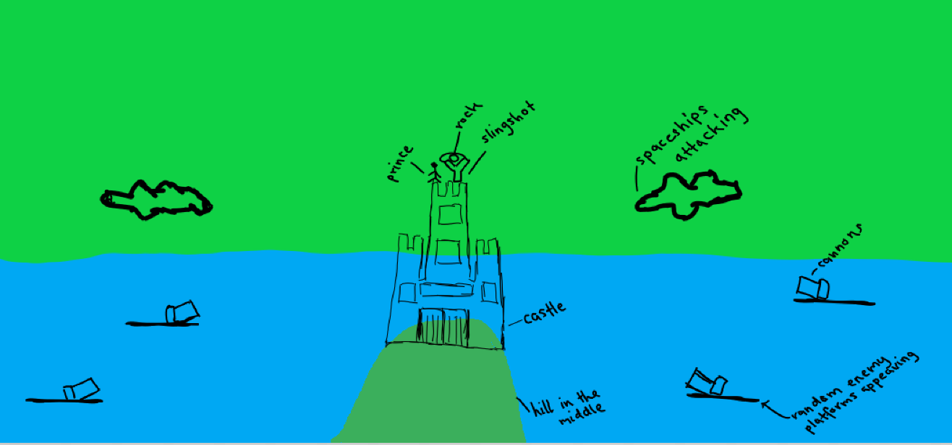

How do you plan to make your game engaging?

I plan to make it engaging by adding more and more enemies as the game progresses and having spaceships attack from the top. Their speed will also increase if the prince doesn’t does not kill the enemies on time.

I will complete this game on the visual studio code and be using matter.js. The player can play this game on tablet, laptop or phone by using the touch screen to move the slingshot.